OEIT 6, Data Analytics, 2022

Lab 5: Apriori Algorithm and Association rule mining with WEKA

Objective;

**Association Mining** is defined as finding patterns, associations, correlations, or casual structures among sets of items or objects in transaction dataset, relational database, and other information repositories. The association rule takes the form of if … then… statement of the form:

**A => B (read as, if A then B)**

Performance measures for association rules:

**Support:**

**support (A => B)= P(A ∩ B)**

The minimum percentage of instances in the database that contain all items listed in a given association rule.

**number of instances containing both A and B**

**support (A => B)=**

**Total Number of instances**

Example:

5000 transaction contain milk and bread in a set of 50000

➔ Support=> 5,000/50,000=10%

**Confidence:**

**confidence (A=> B) = P(B|A)**

Given a rule of the form “if A then B”, rule for confidence is the conditional probability that B is true when A is known to be True.

**number of instances containing both A and B**

**confidence (A => B)=**

**number of instances containing A**

Example:

IF Customer purchases milk THEN they also purchase bread:

In a set of 50,000, there are 10,000 transactions that contain milk, and 5,000 of these contain also bread.

➔ Confidence => 5,000/10,000=50%

Apply Apriori Algorithm to given dataset

Association Rule Mining with WEKA

**Task**

Consider dataset “Groceries” and apply apriori algorithm on it. What are the first 5 rules generated when the min support is 0.001 (0.1%) and min confidence is 0.9 (90%) .

**Exercise 1**: Basic association rule creation manually

The 'database' below has four transactions. What association rules can be found in this set, if the minimum support (i.e coverage) is 60% and the minimum confidence (i.e. accuracy) is 80% ?

|  |  |
| --- | --- |
| **Trans_id** | **Itemlist** |
| T1 | {K, A, D, B} |
| T2 | {D, A C, E, B} |
| T3 | {C, A, B, E} |
| T4 | {B, A, D} |

*Hint: Make a tabular and binary representation of the data in order to better see the relationship between Items. First generate all item sets with minimum support of 60%. Then form rules and calculate their confidence base on the conditional probability P(B|A) = |B∩A| / |A|. Remember to only take the item sets from the previous phase whose support is 60% or more.*

**Exercise 2:** Input file generation and Initial experiments with Weka's association rule discovery.

1. Launch Weka and try to do the calculations you performed manually in the previous exercise. Use the apriori algorithm for generating the association rules.

The file may be given to Weka in e.g. two different formats. They are called ARFF (attribute-relation file format) and CSV (comma separated values). Both are given below:

ARFF:

@relation exercise

@attribute exista {TRUE, FALSE}

… @data

TRUE,TRUE,FALSE,TRUE,FALSE,TRUE

…

… CSV:

exista,existb,existc,existd,existe,existk TRUE,TRUE,FALSE,TRUE,FALSE,TRUE

…

…

1. Once Data is loaded Click Associate Tab on top of the window.

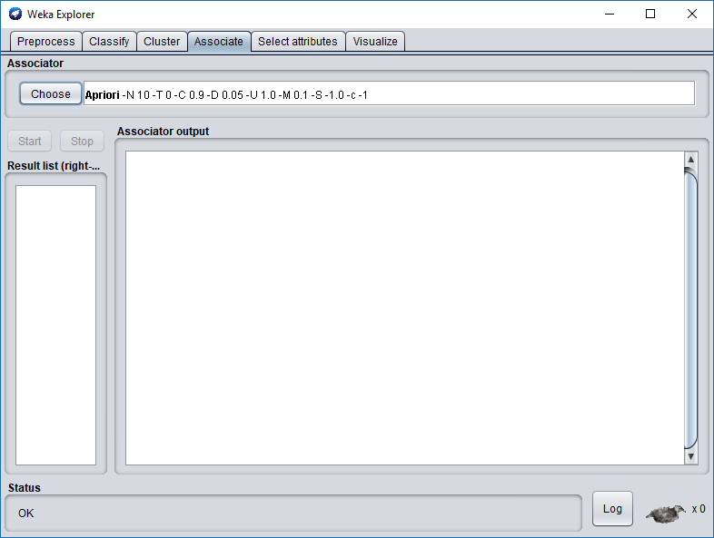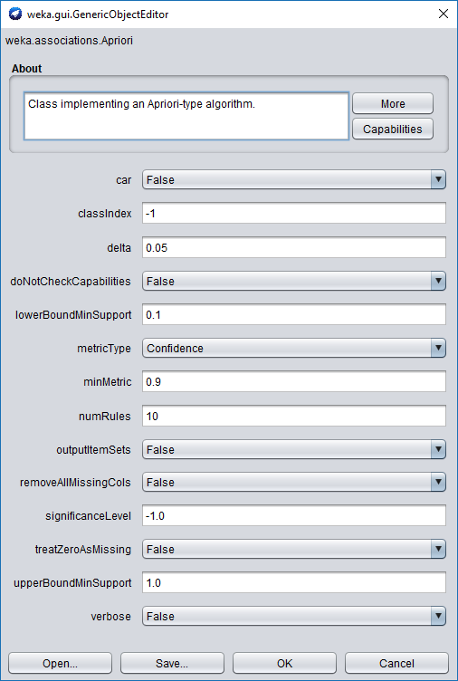

1. Left click the field of Associator, choose Show Property from the drop down list. The property window of Apriori opens.
2. Weka runs an Apriori-type algorithm to find association rules, but this algorithm is not exact the same one as we discussed in class.
   1. The min. support is not fixed. This algorithm starts with min. support as

**upperBoundMinSupport** (default 1.0 = 100%), iteratively decrease it by **delta** (default

0.05 = 5%). Note that *upperBoundMinSupport* is decreased by delta before the basic Apriori algorithm is run for the first time.

* 1. The algorithm stops when **lowerBoundMinSupport** (default 0.1 = 10%) is reached, or required number of rules – **numRules** (default value 10) have been generated.
  2. c. Rules generated are ranked by **metricType** (default Confidence). Only rules with score higher than **minMetric** (default 0.9 for Confidence) are considered and delivered as the output.
  3. If you choose to show the all frequent itemsets found, **outputItemSets** should be set as True.

1. Click Start button on the left of the window, the algorithm begins to run. The output is showing in the right window.

Did you succeed? Are the results the same as in your calculations? What kind of file did you use as input?

**Exercise 3:** Mining Association Rule with WEKA Explorer – Weather dataset

1. To get a feel for how to apply Apriori to prepared data set, start by mining association rules from the weather.nominal.arff data set of Lab One. Note that Apriori algorithm expects **data that is purely nominal: If present, numeric attributes must be discretized first.**
2. Like in the previous example choose Associate and Click Start button on the left of the window, the algorithm begins to run. The output is showing in the right window.
3. You could re-run Apriori algorithm by selecting different parameters, such as lowerBoundMinSupport, minMetric (min. confidence level), and different evaluation metric (confidence vs. lift), and so on.

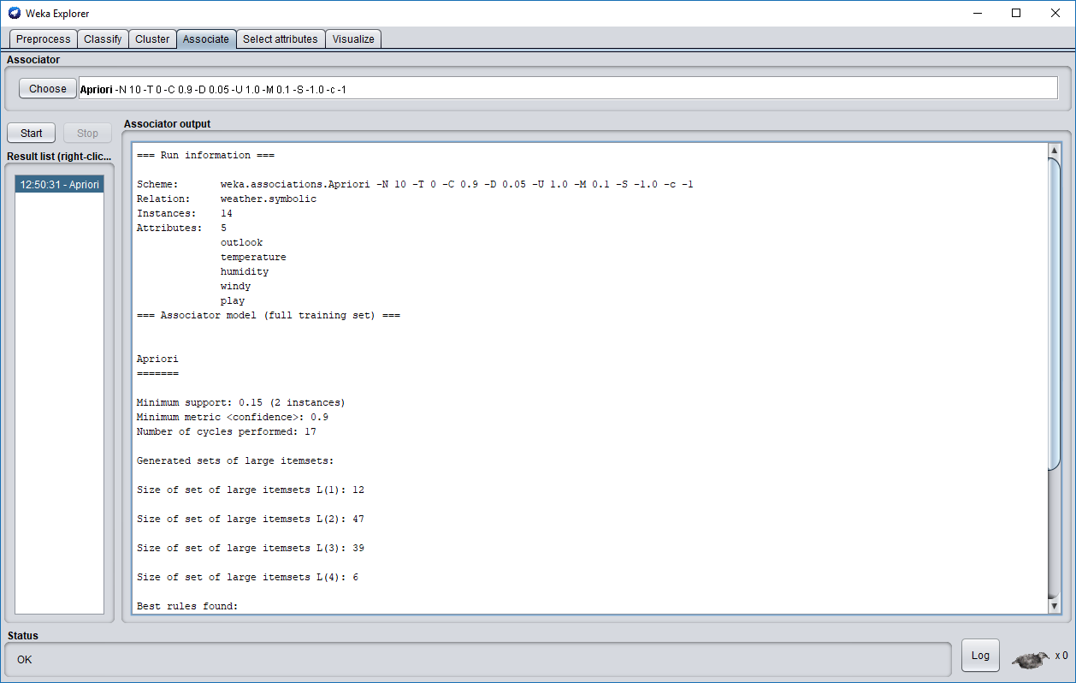

The algorithm starts with min. support as 100% and stops at 15% after running 17 times.

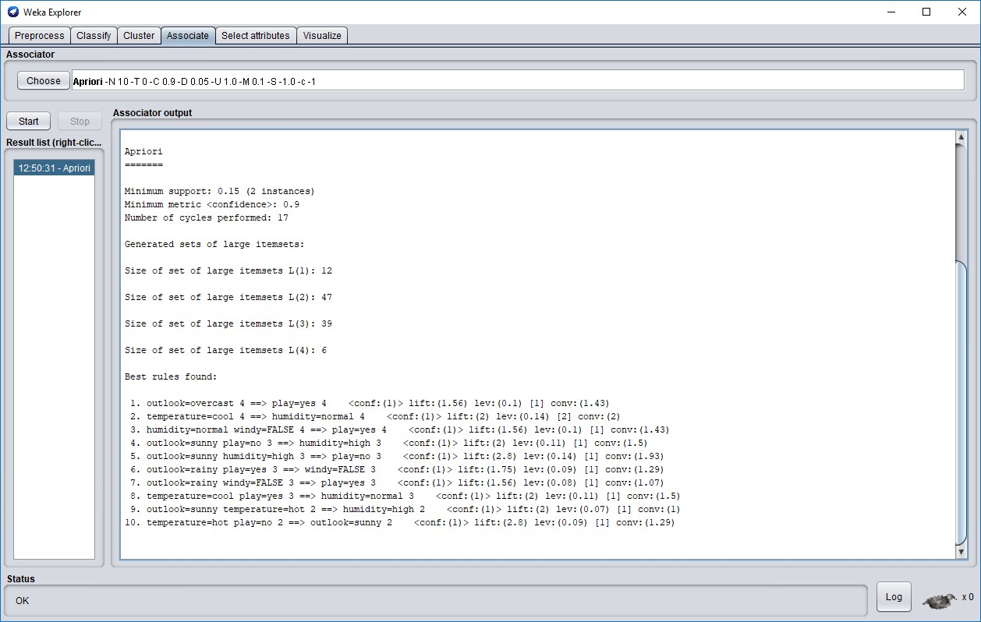

**Exercise 4:** Mining Association Rule with WEKA Explorer – Vote

Now consider a real-world dataset, **vote.arff**, which gives the votes of 435 U.S. congressmen on 16 key issues gathered in the mid-1980s, and also includes their party affiliation as a binary attribute. Association-rule mining can also be applied to this data to seek interesting associations.

Load data at Preprocess tab. Click the Open file button to bring up a standard dialog through which you can select a file. Choose the **vote.arff** file. To see the original dataset, click the **Edit** button, a viewer window opens with dataset loaded. This is a purely nominal dataset with some missing values (corresponding to abstentions).

**Task 1**. Run Apriori on this data with default settings. Comment on the rules that are generated. Several of them are quite similar. How are their support and confidence values related?

**Task 2.** It is interesting to see that none of the rules in the default output involve Class = republican. Why do you think that is?

**Exercise 5:** Let’s run Apriori on another real-world dataset.

Load data at Preprocess tab. Click the Open file button to bring up a standard dialog through which you can select a file. Choose the **supermarket.arff** file. To see the original dataset, click the **Edit** button, a viewer window opens with dataset loaded.

To do market basket analysis in Weka, each transaction is coded as an instance of which the attributes represent the items in the store. Each attribute has only one value: If a particular transaction does not contain it (i.e., the customer did not buy that item), this is coded as a missing value.

**Task 1.** Experiment with Apriori and investigate the effect of the various parameters described before. Prepare a brief oral presentation on the main findings of your investigation.

**Reference Example:**

Input : A large supermarket tracks sales data by SKU( Stoke Keeping Unit) (item), and thus is able to know what items are typically purchased together. Apriori is a moderately efficient way to build a list of frequent purchased item pairs from this data.

Let the database of transactions consist of the sets {1,2,3,4}, {2,3,4}, {2,3}, {1,2,4}, {1,2,3,4}, and {2,4}.

Output Each number corresponds to a product such as "butter" or "water". The first step of Apriori to count up the frequencies, called the supports, of each member item separately:

Item Support

1. 3
2. 6
3. 4
4. 5

We can define a minimum support level to qualify as "frequent," which depends on the context. For this case, let min support = 3. Therefore, all are frequent. The next step is to generate a list of all 2-pairs of the frequent items. Had any of the above items not been frequent, they wouldn't have been included as a possible member of possible 2-item pairs. In this way, Apriori prunes the tree of all possible sets.

Item Support

{1,2} 3

{1,3} 2

{1,4} 3

{2,3} 4

{2,4} 5

{3,4} 3

This is counting up the occurrences of each of those pairs in the database. Since minsup=3, we don't need to generate 3-sets involving {1,3}. This is because since they're not frequent, no supersets of them can possibly be frequent. Keep going:

Item Support

{1,2,4} 3

{2,3,4} 3